

SCHOOL *of* BUSINESS AND TECHNOLOGY

Department of Engineering and Aviation Sciences

**Design of a Virtual Reality Game-Based Learning Module for Engineering Education**

**Zachary Allen**

Advisor: Dr. Zhang

Started: March 3, 2019

Design of a VR Game-Based Learning Application

By

Zachary Allen

Submitted to the Department of Engineering and Aviation Sciences in partial fulfillment of the requirements for the degree of Bachelor of Science in Engineering at the

UNIVERSITY OF MARYLAND EASTERN SHORE

Date

The author hereby grants the University of Maryland Eastern Shore permission to reproduce and distribute publicly, paper and or electronic copies of this document in whole or in parts.

Authors Zachary Allen

Signature

Date

Department of Engineering and Aviation Sciences

Certified by

List of Contents

List of Contents 3

List of Figures 2

List of Tables 3

Abstract 4

1. Introduction 5

1.1 Background/Motivation 5

1.2 Objective 7

1.3 Design Requirements 7

1.4 Design Constraints 7

1.5 Design Approach 7

2. Project Description 9

2.1 System Description 9

2.2 System Diagram 9

2.3 System Functions 9

3. Implementation Plan 10

3.1 Tasks 10

3.2 Team Organization 11

3.3 Timeline/Milestones/Delivery Plan 11

4. Implementation 12

4.1 Implementation of Task 1. 12

4.1.1. Implementation of Subtask 1A 12

4.1.2. Implementation of Subtask 1B 12

4.1.3. Implementation of Subtask 1C 13

4.2 Implementation of Task 2. 13

4.2.1. Implementation of Subtask 2A 14

4.2.2. Implementation of Subtask 2B 14

4.2.3. Implementation of Subtask 2C 16

4.3 Implementation of Task 3 18

4.3.1. Implementation of Subtask 3A 18

4.3.2. Implementation of Subtask 3B 18

4.3.3. Implementation of Subtask 3C 19

4.3.4. Implementation of Subtask 3D 20

4.3.5. Implementation of Subtask 3E 20

4.4 Implementation of Task 4 21

4.4.1. Implementation of Subtask 4A 21

4.4.2. Implementation of Subtask 4B 22

4.4.3. Implementation of Subtask 4C 22

4.4.4. Implementation of Subtask 4D 23

4.5 Implementation of Task 5 23

4.5.1. Implementation of Subtask 5A 23

4.5.2. Implementation of Subtask 5B 23

4.5.3. Implementation of Subtask 5C 24

4.6 Implementation of Task 6 24

4.6.1. Implementation of Subtask 6A 25

4.6.2. Implementation of Subtask 6B 26

4.7 Implementation of Task 7 27

5. Conclusion (Discussion and Future Plans) 28

Acknowledgment 29

Appendix 30

A. Assets Used 30

1. Standard Assets – by Unity 30

2. UI – by Unity 30

3. SteamVR – by Valve 30

4. Bodyguards – by Batewar 30

5. Modern Weapons Pack – by 7XF Desifn 30

6. Modular Factory Environment – by Ogasoda 30

7. Equipment for Indurtial of Science – by Sevastian Marevov 30

8. Nature Starter Kit 2 – by Shapes 30

B. Source Code. 30

1. Basic Enemy.cs 30

2. Basic Enemy Health.cs 31

3. PlayerHealth.cs 31

4. Boss Enemy.cs 32

5. Boss Health.cs 32

6. Aggroed.cs 33

REFERENCES 35

List of Figures

[Figure 1 - People Playing a Game Together 4](#_Toc23335121)

[Figure 2 - An Example of a VR Headset 5](#_Toc23335121)

[Figure 3 - Design Approach 7](#_Toc23335121)

[Figure 4 - The Game's System Diagram 8](#_Toc23335121)

[Figure 5 - The Game's Original Structure 11](#_Toc23335121)

[Figure 6 - The Scenes Folder, Showcasing the Game's Structure 12](#_Toc23335121)

[Figure 7 - The First Room 13](#_Toc23335121)

[Figure 8 - First Hallway 14](#_Toc23335121)

[Figure 9 - Second Hallway 14](#_Toc23335121)

[Figure 10 - Third Hallway 15](#_Toc23335121)

[Figure 11 - Broken 4th Hallway 15](#_Toc23335121)

[Figure 12 - Eyes of the Eldritch 16](#_Toc23335121)

[Figure 13 - Overhead View of Last Hallway 16](#_Toc23335121)

[Figure 14 - The Decimal to Binary Puzzle 17](#_Toc23335121)

[Figure 15 - Minterm and Maxterm Puzzle Room 18](#_Toc23335121)

[Figure 16 - Boolean Algebra Puzzle Room 18](#_Toc23335121)

[Figure 17 - K-Map Puzzle Room 19](#_Toc23335121)

[Figure 18 - Final Puzzle Room Layout 20](#_Toc23335121)

[Figure 19 - Teleporting as Shown in the Unity Editor 21](#_Toc23335121)

[Figure 20 - T-Posing Model of the Security Enemy 23](#_Toc23335121)

[Figure 21 - The Senturion in Question 23](#_Toc23335121)

[Figure 22 - Two Workers Slacking 24](#_Toc23335121)

[Figure 23 - Overhead View of the Working NPC 24](#_Toc23335121)

[Figure 24 - The Plane to Space 25](#_Toc23335121)

[Figure 25 - The Main Menu 26](#_Toc23335121)

List of Tables

Table I - Planned Project Timeline 15

Abstract

This project combines engineering learning and virtual reality technology to produce a game-based learning module. This project intends to teach the players digital logic circuits while keeping them engaged with exploring the game and shooting down enemies. The game is built within Unity itself in conjunction to many assets to help design the game. SteamVR is used extensively to allow the game itself to run on virtual reality. With many rooms, 5 puzzles, and many technical hurdles, the project proves to be a major uphill battle from start to finish when considering one person is making a VR video game alone.

1. Introduction

This project will utilize virtual reality and game-based learning to create an ominous puzzle game with shooter elements akin to Call of Duty. The end goal of this project is to provide a game that both allows the players to learn elements taught in a digital-logic circuits classroom and give them time to unwind battling braindead enemies hindering their progress.

## Background/Motivation

For some, video games are a hobby in their everyday lives. Whether they are playing games to relieve themselves from stress after a long day; learn something new, or to entertain an audience on the internet, the video game market can provide enjoyment for just about anyone. Ultimately, the purpose of video games is to provide fun, enjoyment, and replayability for the consumers. Video games can also serve as a means to bring various people together like shown in Figure 1. People from various backgrounds can come together through a single hobby they enjoy.

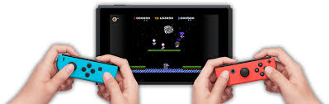

Figure - People Playing a Game Together

For others, video games are long, strenuous projects that must be built as a development team for consumers to buy. In an ideal world, developers would work throughout the week with little overtime and no development crunch to release the right game for the right audience. Of course, even a released video game does not get produced perfectly. Issues may pop up after the video game reaches the shelf.

Today, video games are being viewed in the media in a negative light. With recent shootings around America being linked to video games, the media is under the impression that video games enable its players to be more violent than the generation before. With this portrayal being relevant in the news cycle, the challenge becomes making a video game that is made passionately and prove that not all video games enable its players to be violent.

While some video game developers are major corporations creating high-budget games designed to bring in a lot more money then what went into the game, others are small teams of people creating a passion project to share with the world. No matter who the developers are, most video games are crafted with care, attention, and intent to produce an impact on their fans. With the introduction of more efficient video game crafting tools, anyone can join the video game development with the right amount of practice and dedication.

For instance, one tool people could use to create video games is Unity. The unity website provides a free version for anyone to get started with and more advanced versions should they decide to make a career out of producing games. Unity also provides an asset store for people to use to help craft their game to suit their big design. They also have an active forum and classes to help aspiring developers learn the system and produce a game in no time.

Suppose someone wanted to create an edutainment game on Unity. Some people may think to themselves, “Why bother? Are these games only meant for young kids?” On the contrary, edutainment games do not have to be restricted to just the young. There is a potential market to bring such video games to high school and even college. A game can be made to teach more advanced concepts while providing moments to turn off their brains after thinking on a puzzle for so long.

Perhaps an immersive video gaming experience could help breathe new life into edutainment video games. With virtual reality technology breathing new life and brimming with more potential than ever before, edutainment games could seek a new home in VR gaming. All they would need is a VR headset like the one shown in the figure below. This surging technology could provide more means to teach students more educational subjects than ever before while including breaks from learning.

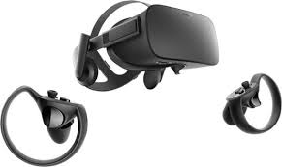

Figure - An Example of a VR Headset

This idea of combining video gaming with education is called game-based learning, also known as GBL. An example idea of a game-based learning application is to use a puzzle game similar to the 3D *Legend of Zelda* games combined with a shooter game such as *Call of Duty*. This combination allows the player to solve puzzles teaching various concepts taught in class such as a class on circuitry while also letting them unwind between puzzles by mindlessly shooting down enemies. Ideally, the GBL application would have an equal mix between shooting and learning so the player is learning without being burnt out from just learning without a moment to relax.

## Objective

The overarching goal of the project is to create a game for engineering students learning digital logic circuits that both teach them elements of the class and engages them in the game world.

## Design Requirements

The game will take about half an hour to complete. There will be characters and objects to interact with. These interactions are either chatting with friendly NPCs, knocking out enemies, or using objects available to complete a given puzzle. The game itself will have 5 puzzles to solve with permanent rewards for the first 4 puzzles to assist the player. The game will also utilize teleportation to work over the limited play area virtual reality provides. The game will end with a 5-question quiz that will serve as the final battle. Essentially, this design will result in a puzzle + shooter action game with unnerving elements throughout.

## Design Constraints

The virtual reality technology provided by the institution provides the biggest restraint in this project. The labs utilize the HTC Vive virtual reality headset; and therefore, the game must run with this headset in mind. The headset itself is wired, so the game must be built to provide functions to work over the limited play area as in the SteamVR’s teleportation feature. Because of the nature of virtual reality gaming, prolonged exposure can result in headaches. This will severely limit the duration of the game itself. Considering this restriction, the game’s duration ended up being about 30 minutes.

## Design Approach

The design for this game is split into three intertwined parts: the story, the world, and the puzzles. Without a story, there is no reason for the world to exist. Without the puzzles, there is no reason to create this game utilizing GBL. Without the world, there is no gam. In order to create the game, the story must be established.

In this case, the story involves the player winding up deep within an engineering facility. They must get a feel of their situation and try to escape the facility. Along the way, the player will encounter two types of enemies. The first are the previous people who were rendered braindead from struggling to solve the puzzles. The second is the security guards sent by the facility’s boss as a result of fear for the facility’s secrets being exposed. After being confronted by the boss, the player will be challenged to one last quiz and then sent to an unknown facility somewhere in space.

The world is developed based on the story. The world takes place within a hidden testing chamber of an engineering facility. The facility was purposed to teach their trainees digital logic circuits. However, years have passed, and no one has solved all four of its puzzles. These trainees have become braindead and with attack anyone who gets in their line of sight. Over time, the player will learn than the facility is holding a secret the boss does not want to have leaked. The boss will send security to stop the player the closer they are to the end.

From there, the basis for what the player will see can be made. There will be a visible health bar with the health having a max value that increases twice throughout the puzzles. The puzzles will also award players with two weapon upgrades just in time for the elite enemies towards the end. Because of the limited movement space, the player will also be allowed to teleport to bypass this limitation. Since each room and hallway will be its own scene in Unity, each time a new scene is loaded, that scene will become the respawn point should the player lose their health points. The approach will be highlighted in the figure below taking all the points from this section of the report into consideration.

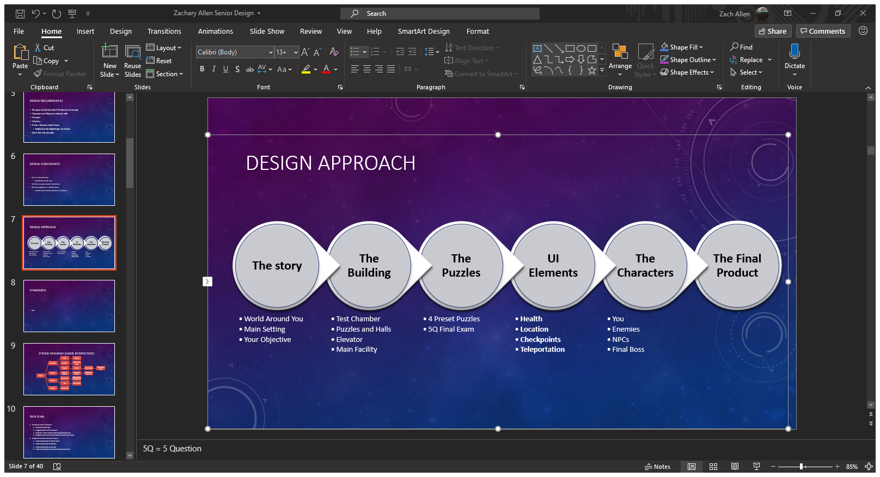

Figure - Design Approach

1. Project Description

## System Description

This game will utilize Unity and virtual reality. The player’s movements combined with their controller inputs dictate how the game is controlled. There will be button inputs for helping with puzzles, beating down enemies, and teleporting around rooms larger than the VR play area.

## System Diagram

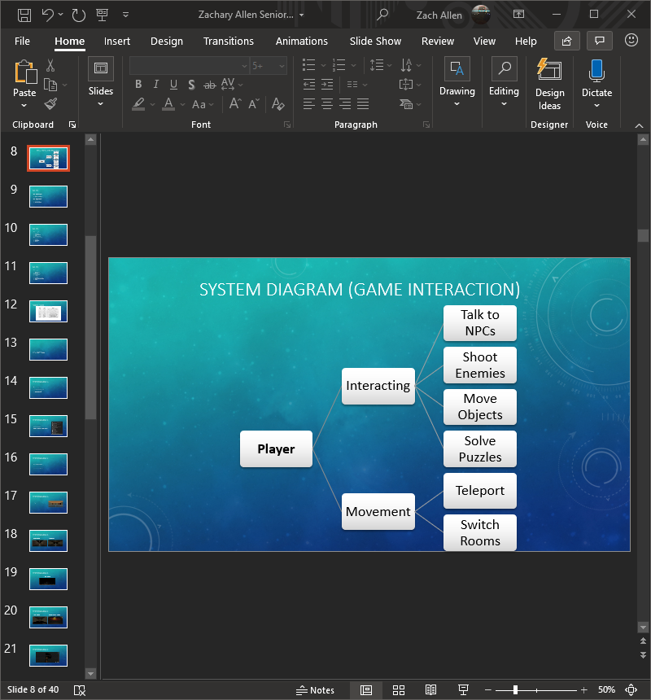

Figure - The Game's System Diagram

## System Functions

The game will feature two different systems that interact with each other and the game. The game has 4 different Interactions. The first one deals with communication with non-hostile NPCs. The second interaction involves shooting down enemies that get in your way. The third interaction is moving objects around to coincide with the final interaction of solving puzzles to get rewards that will help with player progression.

The second system is the game’s Movement system. While the game world can be interacted with by normal walking, the scenes themselves are much bigger than the available play area with a wired HTC Vive headset. Therefore, the first system for movement involves teleportation, which is part of the project’s implementation process. This allows the player to circumvent the limited play area and go through the full game. Since each room will be loaded separately, the second movement system is implemented to be able to switch from one room to the next until the end of the game.

1. Implementation Plan

## Tasks

* Task 1: Design the Game’s Foundation
  + Subtask A: Develop the Game’s Plot
  + Subtask B: Establish the Game’s Structure
  + Subtask C: Designate Assets to Create the Project
* Task 2: Design the Hallways of the Game
  + Subtask A: The Starting Room
  + Subtask B: Basic Hallways
  + Subtask C: Advanced Hallways
* Task 3: Design the Puzzle Rooms
  + Subtask A: Decimal to Binary
  + Subtask B: Minterms and Maxterms
  + Subtask C: Boolean Algebra
  + Subtask D: K-Map
  + Subtask E: Digital Logic Circuit Design
* Task 4: Create the Game’s UI Elements
  + Subtask A: Enable Teleportation
  + Subtask B: Create an HP System
  + Subtask C: Establish Interactivity with the Objects
  + Subtask D: Make the Checkpoint System
* Task 5: Design the Game’s Enemies
  + Subtask A: Braindead Trainees
  + Subtask B: Regular Security Patrol
  + Subtask C: The Boss’ Elite Guard
* Task 6: Create the Main Lobby
  + Subtask A: A Live Office
  + Subtask B: The Final Exam
* Task 7: Verify the Program
  + Subtask A: Ensure Every Event Works Properly
  + Subtask B: Ensure Each Scene is Loaded One After Another
  + Subtask C: Debug the Game

## Team Organization

This project will be completed by one person. As such, Zachary Allen will be solely responsible for the completion of each task shown in the timeline. The timeline below shows what is to be expected after each week until it is time for the final presentation

## Timeline/Milestones/Delivery Plan

Table - Planned Project Timeline

|  |  |  |
| --- | --- | --- |
| Week | Tasks | Details |
| 1-2 | 1A, 1B, 1C | Create the Foundation for the Game |
| 3-4 | 2A, 2B, | Design the Hallways between Puzzles |
| 5 | 2C | Create the final hallways |
| 6-7 | 3A, 4A, 4C | Start the Puzzle Room and UI Elements |
| 8-11 | 5A | Create the First Enemy |
| 12-14 | 4B, 4D | The Rest of the UI is made |
| 16-18 | 3B, 3C, 3D | The Other Puzzles are developed |
| 19 | 3E, 5B, 5C | The Harder Enemies are made |
| 20 | 6A, 6B | Create the endgame |
| 21-22 | 7A, 7B, 7C | Verify that the entire game works. |

1. Implementation

This section of the report will go through each task and mention how they have been implemented throughout the project.

## Implementation of Task 1.

This task is meant to develop the cornerstone for this entire game. This means the story, structure, and assets used are determined in this task. By establishing a foundation for the game, the rest of the tasks can follow suit as the game is being developed.

### Implementation of Subtask 1A

This task established the plotline for this game. For this adventure, the player is a trainee who got trapped within the facility’s training chambers. The player wakes up and must try to leave the chamber. They will solve the facility’s digital logic circuit puzzles and take down other trainees who became braindead throughout the testing process. As the game goes on, the player will learn that the antagonist did not mean for anyone to clear the chambers and will start to send his security personnel to stop the player. After confronting the boss and clearing his final exam, the player will be sent away so the boss’s secrets can remain hidden from the public eye. Where the player ends up is the basis for another GBL Senior Design Project involving puzzles in circuits.

### Implementation of Subtask 1B

Now that the game’s story is set, the task to develop the game’s structure is afoot. Originally, the game would take place in one large chamber with winding hallways connecting to each puzzle room as shown in the figure below. However, this idea was eventually scrapped after realizing the player could not realistically navigate a large, winding facility.

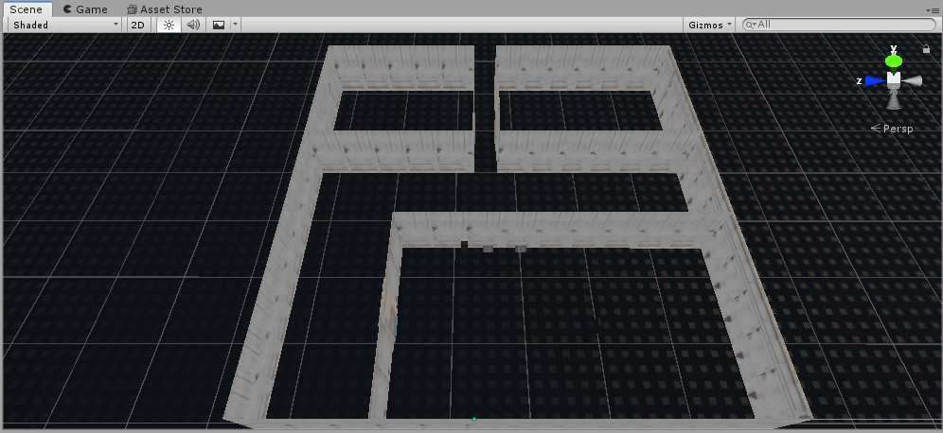

Figure - The Game's Original Structure

Therefore, the game took on a new structure. This structure takes full advantage of loading scenes in and out while compensating for the limited virtual reality movements. Each room, therefore, became its own scene in the final project with a script loading between each room as the player leaves the room before. This also includes the hallways connecting each room. The way this project is split is shown in the figure below. Each scene is its own unity file in the Scenes folder. Future implementation allows the game to load from one scene to the next within this folder. Even so, the rooms are still bigger than the play area allotted for virtual reality use. Therefore, teleportation must be used as explained later on in the Implementation section.

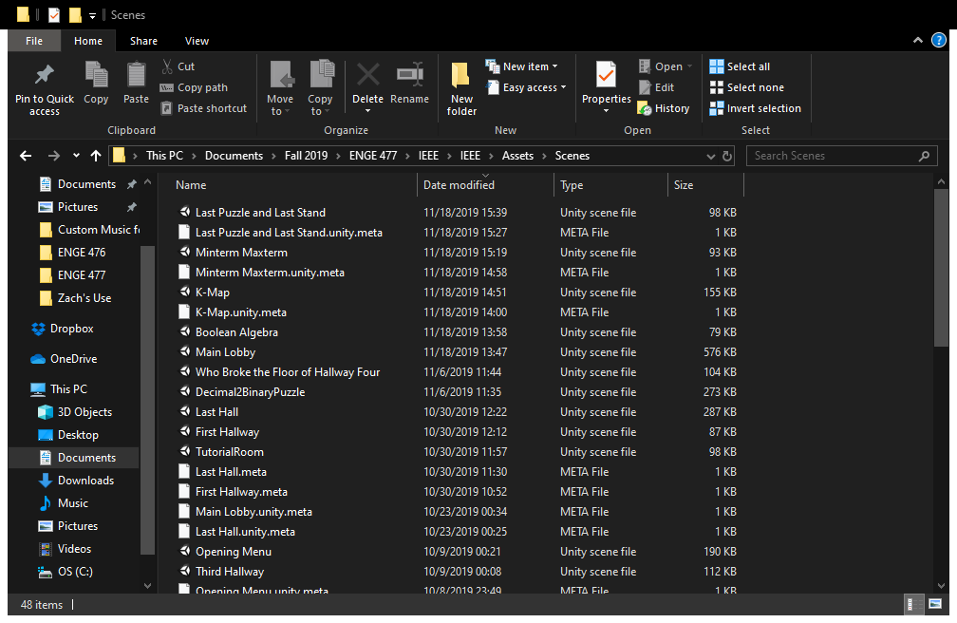

Figure - The Scenes Folder, Showcasing the Game's Structure

### Implementation of Subtask 1C

With the story and structure of the game established, the time came to establish the assets the project will use. All of the assets will be mentioned in the Acknowledgements section with credit to their creators. One important asset to mention, however, is the SteamVR asset. This asset allows this project to run through its full potential by enabling this game to run in virtual reality. This asset almost makes movement through larger rooms possible with teleportation.

## Implementation of Task 2.

This task begins building the rooms the facility will go through. To start things off, the player will begin in the first room of the facility and will then go through a dark hallway to get to the first puzzle. With the structure being room then hallway and then room and so on, the first step would be to create the first room and the hallways to navigate.

### Implementation of Subtask 2A

The game begins in a surprisingly lit room deep inside the testing chambers. In the lore, these rooms are where trainees begin to complete their run through the facility to clear each puzzle. Such a room is implemented as shown in the figure below. The player will use this room to get familiar with the controls and proceed to the first hallway once acclimated with the controls.

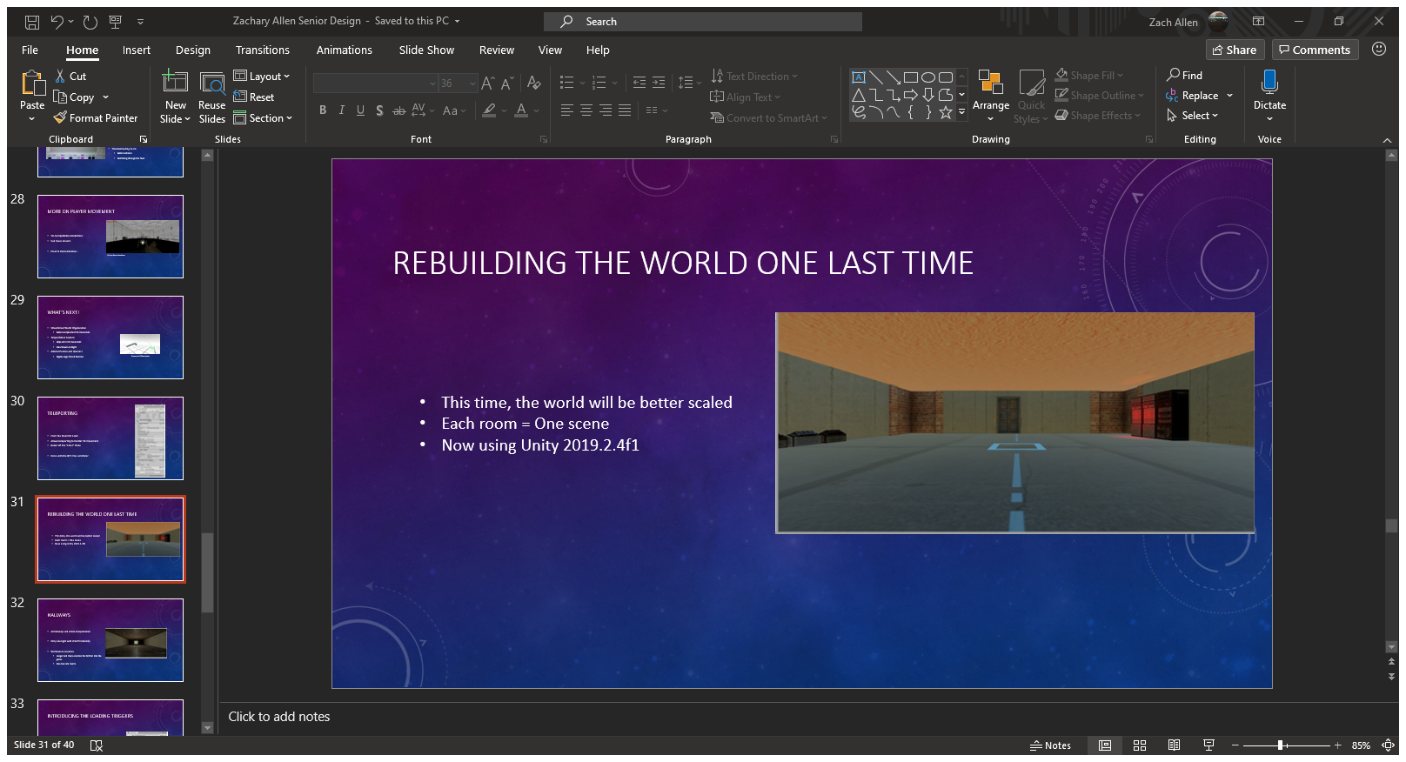

Figure - The First Room

### Implementation of Subtask 2B

Once the first room was built, the next objective was to create the 5 total hallways the game will have. There will be 3 simple-to-navigate hallways and 2 more advanced ones as the game progresses. This subtask focuses on the first 3 hallways. The first hallway is shown in the caption below. This room is very dark compared to the starting room and introduces the player to the first enemy of the game. However, this hallway is short, and the player can easily circumvent the enemies. Clearing this hallway grants the player access to the decimal-to-binary puzzle.

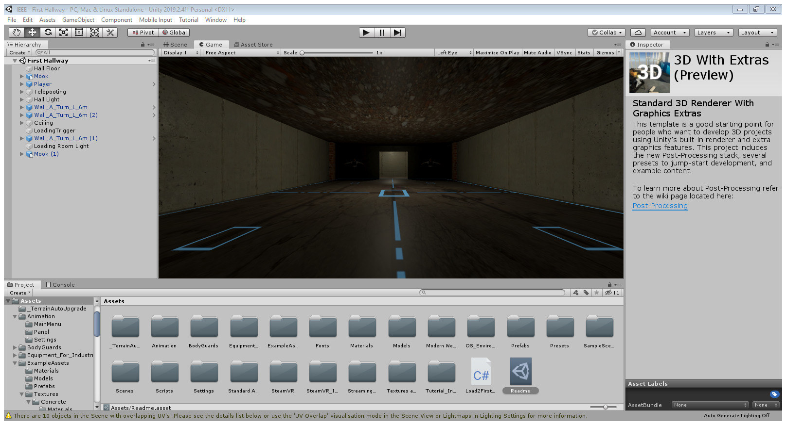

Figure - First Hallway

The second hallway is shown in the next figure below. This hallway is longer than the first one and even has a brief outdoor view. Like the first hallway, this one is a straight shot from point A to point B to get to the next puzzle that will involve minterms and maxterms.

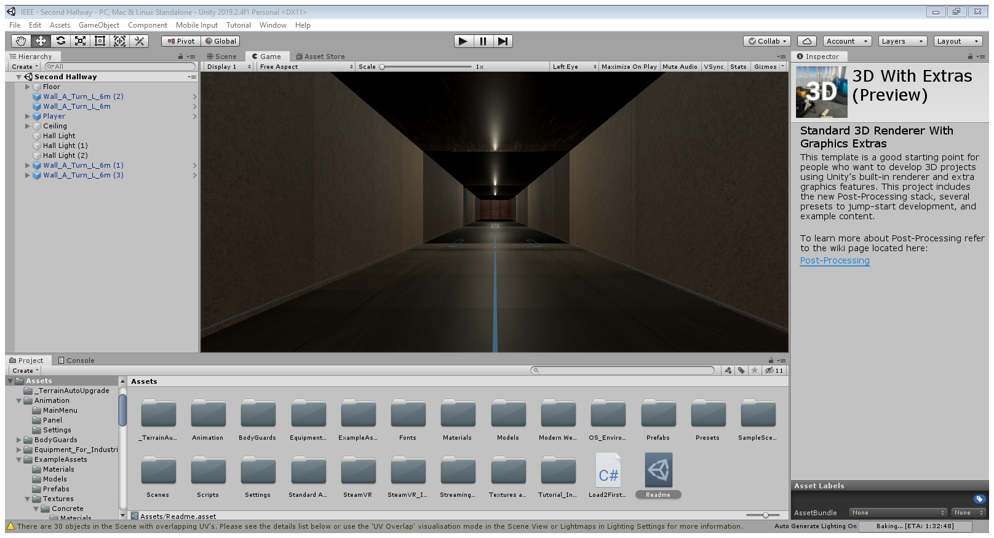

Figure - Second Hallway

The last simple hallway is shown below. This one bends at a 90-degree angle. This hallway will introduce the second enemy type of the game where the story escalated to the boss starting to actively keep the player in the testing facilities. These enemies will have slightly higher health than the first enemy type and are more ruthless. Clearing this hallway sends players to the Boolean algebra puzzle.

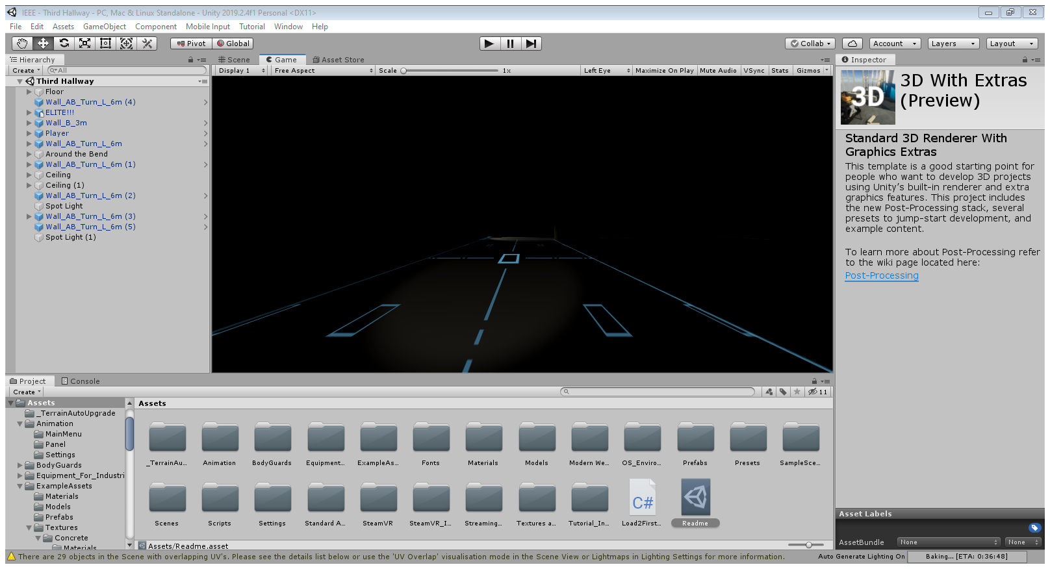

Figure - Third Hallway

### Implementation of Subtask 2C

As mentioned in the above section, this game has 5 hallways. This subtask will implement the final two hallways the player will encounter. The first one is shown below. Here, the player must teleport between chopped off sections of flooring and avoid falling to meet the past victims of this accursed hallway. Once they clear this platforming section, they are granted access to the K-Map puzzle.

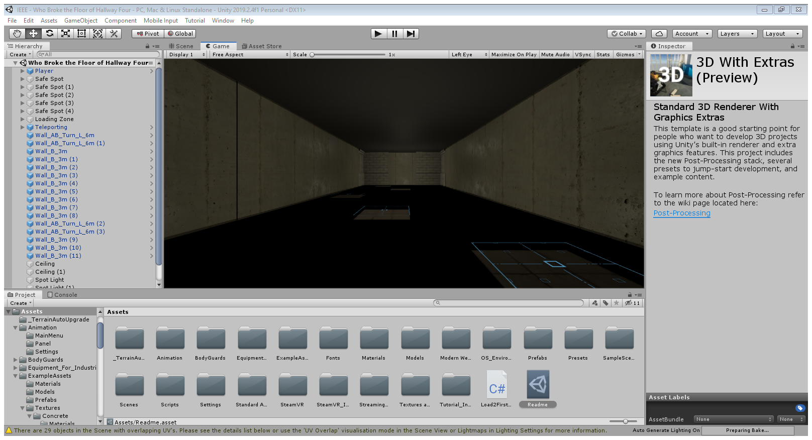

Figure - Broken 4th Hallway

One more thing to note about the fourth hallway is the creature showcased in the following figure. This is the “Eyes of the Eldritch.” It is an unknown entity with unknown origins and no natural explanation as to why it is under this hallway and why it broke the hallway. Many unfortunate souls have fallen to the eldritch in their journey of the chambers. One has to wonder if the player will be next….

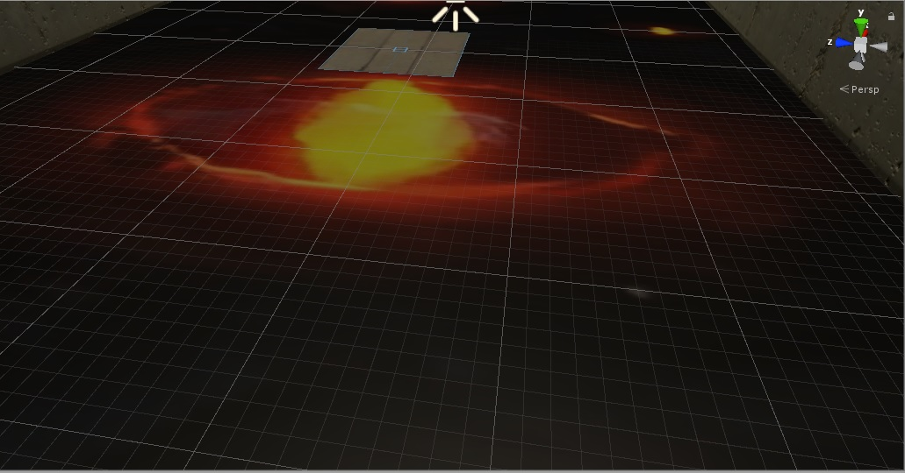

Figure - Eyes of the Eldritch

The last hallway is represented by the figure below. This hallway features both elevation and broken floors. The end of the hallway has a boss battle preventing the player from accessing the final puzzle and the main lobby. Details about the boss is detailed in its respective implementation section.

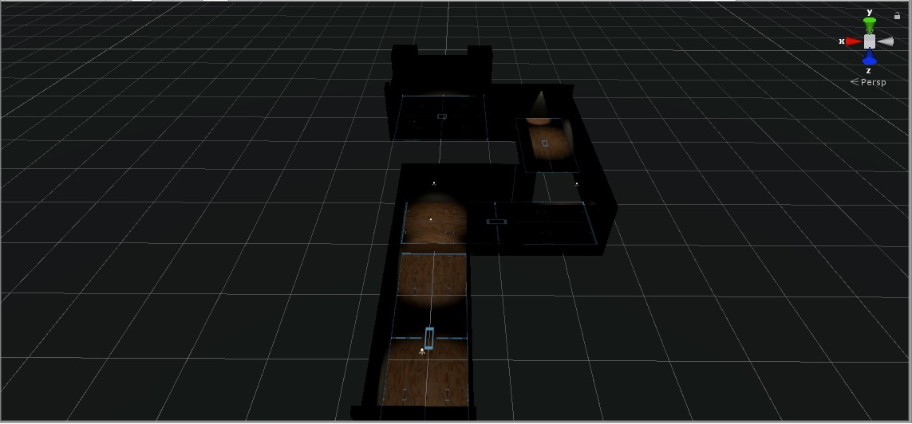

Figure - Overhead View of Last Hallway

## Implementation of Task 3

Once the hallways are built and established, the next task of creating the puzzles can be implemented. The purpose of these puzzles is to test the player’s knowledge of digital logic circuits. The first four puzzles also come with a reward system that will help the player in their journey. Completing the final puzzle will grant the player access to the main lobby and the end game.

### Implementation of Subtask 3A

The first puzzle has the player doing a simple conversion from decimal to binary. This puzzle has 2 parts: the first conversion and then taking the 2’s complement of the first number. The player will need to know numbers from -512 to +1023 to be able to do the conversion since the puzzle uses a 10-bit system. For this puzzle, the decimal number that will need to be converted to binary and its 2’s complement is 500 in reference to song lyrics posted on the wall.

The puzzle is shown in the figure below. The puzzle consists of 10 lights with respective buttons below. Red lights represent a “0” and green lights represent a “1.” The puzzle defaults to all values being 0. Once the correct combination of 1’s and 0’s is made, the door opens to the 2’s complement puzzle. Completing that puzzle allows the player to enter the next hallway and grants them an extra 25 damage to their attacks. This goes hand in hand with the user interface shown in a later implementation.

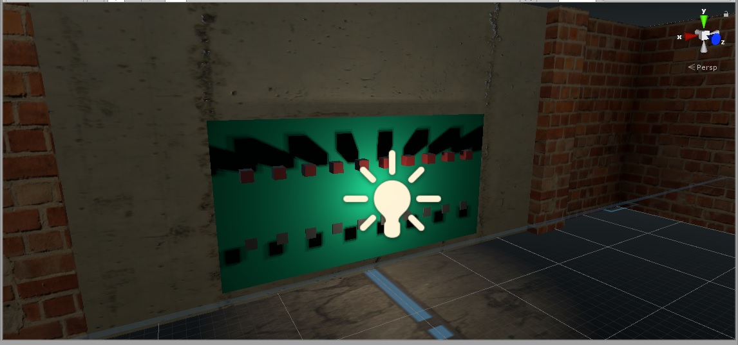

Figure - The Decimal to Binary Puzzle

### Implementation of Subtask 3B

The second puzzle the player will encounter is a simple minterm and maxterm puzzle. The player will be presented with a truth table, 8 sums of the truth table itself as movable boxes, and two baskets labelled “Minterm” and “Maxterm.” By placing each box in the right basket, the player will be able to advance to the 90-degree hallway and continue the game. The player will also be rewarded with 25% reduced damage that will stack with another puzzle’s reward later on.

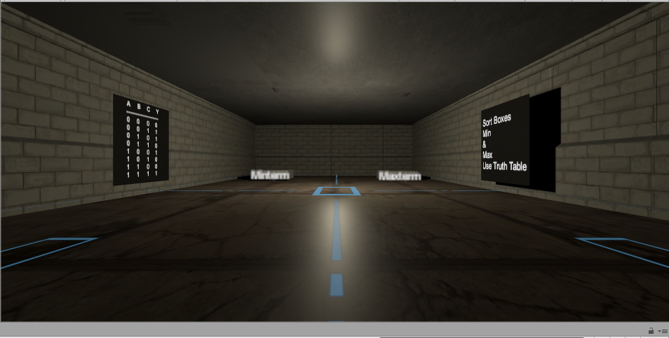

Figure - Minterm and Maxterm Puzzle Room

### Implementation of Subtask 3C

The third puzzle players will encounter involves utilizing Boolean Algebra to simplify two functions presented. The room will feature a post featuring an unsimplified expression. The goal is to use the screen at the end of the room to simplify the expression to solve the puzzle. Each wrong guess will cause a flat 10 damage penalty, so the player must plan accordingly before throwing random guesses into the air. Completing this puzzle will reward the second damage boost and allows them to visit the Eyes of the Eldritch.

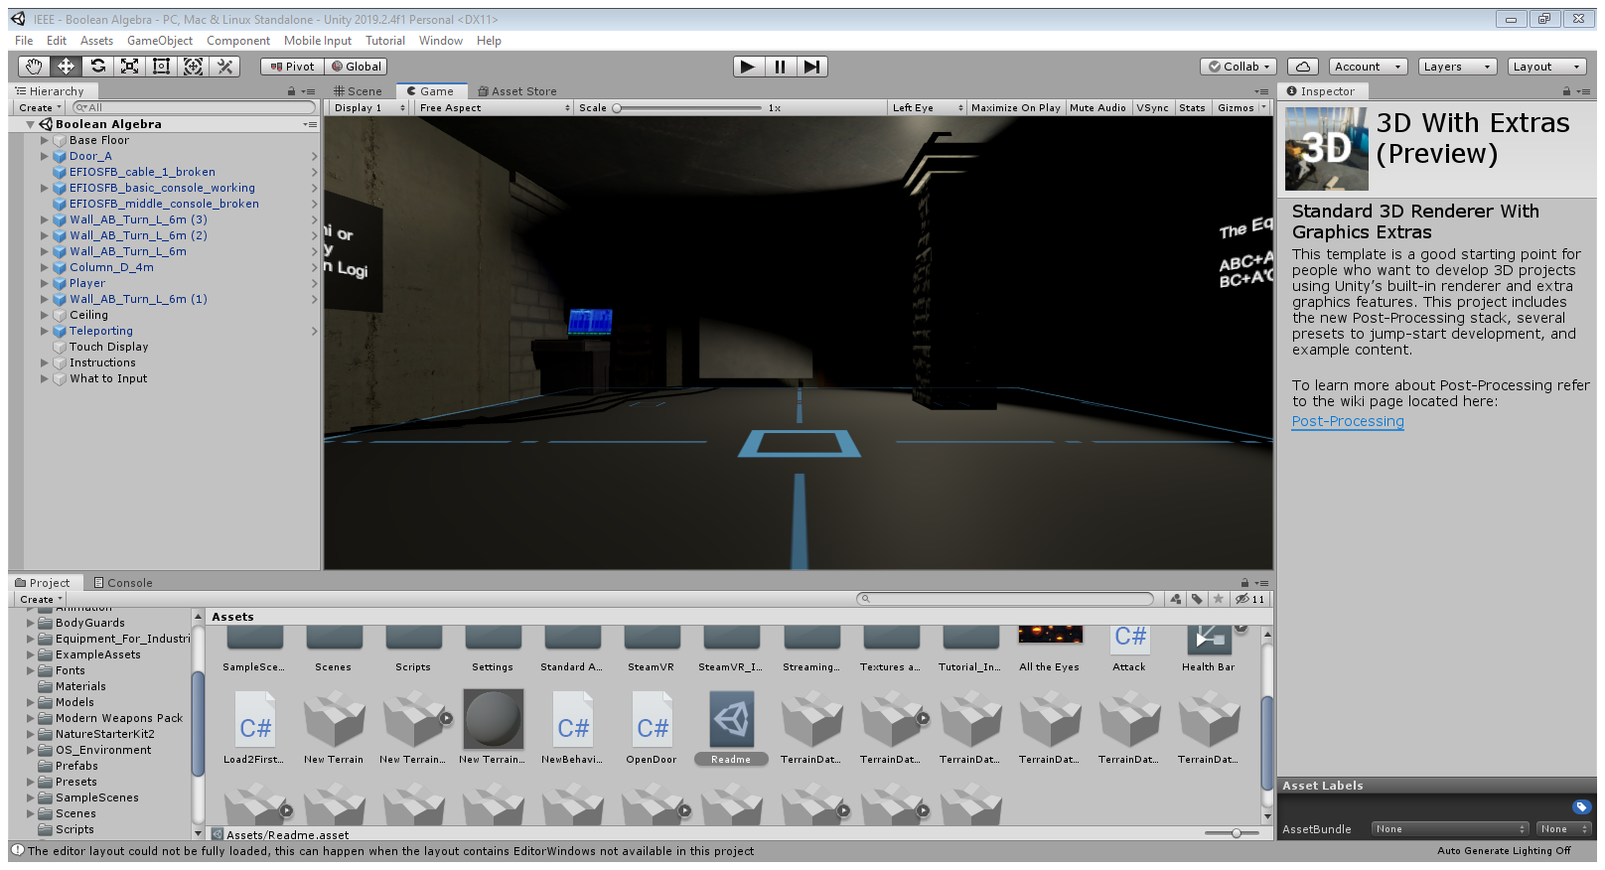

Figure - Boolean Algebra Puzzle Room

### Implementation of Subtask 3D

The next puzzle uses another truth table with 8 lines. However, the room will have 8 squares on the floor. Below this room is the Eyes of the Eldritch. Any incorrect input will drop the player to its eternal deadly stare. The player must step only on the squares that outputs a 1 from the truth table. Therefore, the player is using their feet to create a K-map of the provided truth table. This puzzle presents the final reward of the second 25% damage reduction, just in time for the last hallway and its impending boss battle.

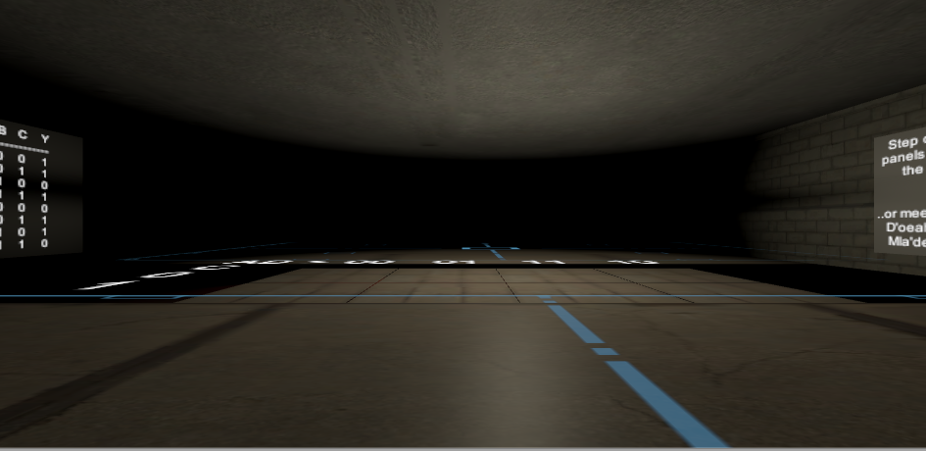

Figure - K-Map Puzzle Room

### Implementation of Subtask 3E

The final puzzle takes what the player has learned over the past four puzzles and requires them to create a Boolean logic circuit. The room will feature an expression and a board with logic gates to put into the proper equation. Only by making the right circuit can the player advance to the main lobby.

Furthermore, the room also comes equipped with an enemy spawner. Every minute the player spends in the puzzle, a second-tier enemy comes to interrupt the puzzle-solving. The player will have to juggle solving the puzzle and control the enemies to ensure proper completion of the puzzle with minimal damage.

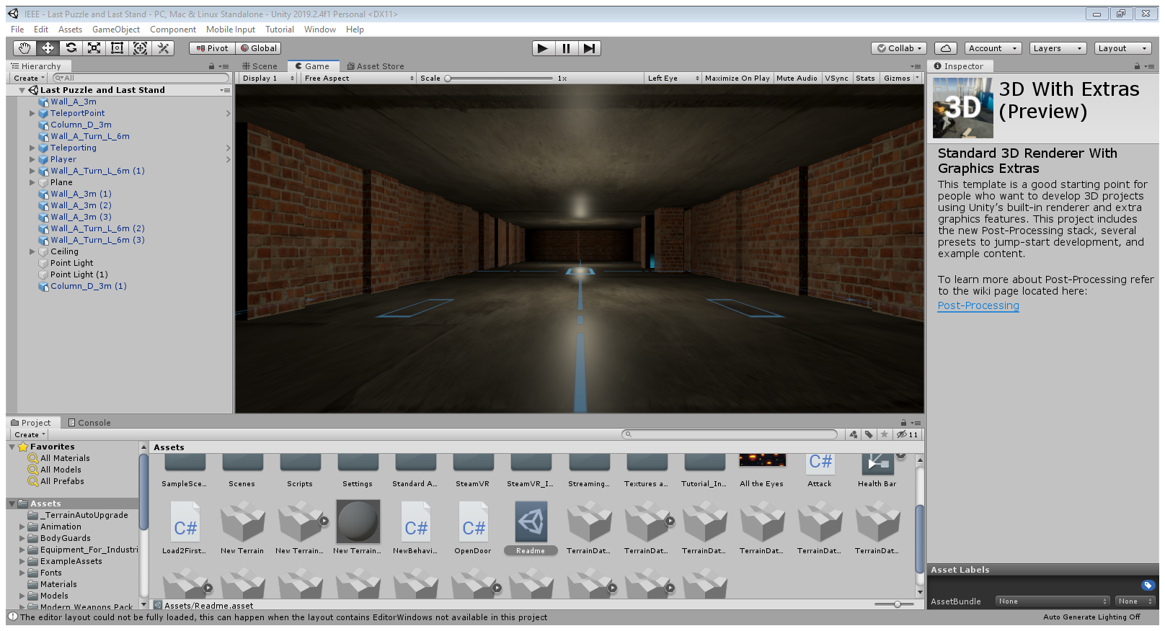

Figure - Final Puzzle Room Layout

## Implementation of Task 4

Once the world is established as well as its puzzles, the user interface elements must be created. This includes the way the player moves around the world, how the world can be interacted with, and how to prevent the player from have to restart the *entire* game after each game over. Since the UI elements of this game is done through C# code, these subtasks will refer to the Appendix for each of the subsections’ respective script file.

### Implementation of Subtask 4A

Because of the limited mobility of the HTC Vive and how large each of the scenes in the game are, basic moving will not be enough to navigate the game. The solution to this problem is to apply teleportation to the game. This is established by using the SteamVR asset in Unity. For the sake of this project, teleportation is achieved by duplicating the floors of each room and establishing a teleportation layer for each floor that has collision. The results of this action are shown in the figure below. The teleporting layer of the floor itself also has to have collision or the teleporting feature cannot be used. The teleportation itself is performed by using the trackpad of the Vive controllers. This action of teleportation will also be utilized to take players between each room and hallway of the game.

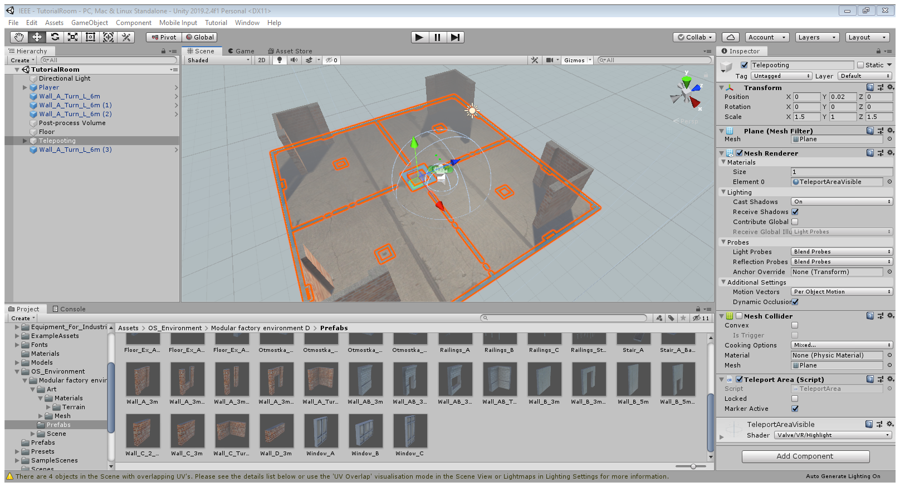

Figure - Teleporting as Shown in the Unity Editor

### Implementation of Subtask 4B

A game is no fun if there is no risk involved with how one plays it. That is why games usually come with a health system to encourage players to think carefully and provide a boost of adrenaline should they make it out of a rough encounter by the skin of their teeth.

This game will also come implemented with a health system. The player will have a base health of 100 with damage modifications that reduces their damage from enemies after solving the second and fourth puzzles. Enemies will also drop healing caplets to heal the player from any damage taken. What happens when the player reaches 0 health will be explained in subtask 4E.

### Implementation of Subtask 4C

In order for the puzzles to work, there must be an ability to interact with the objects in the world. For instance, this subtask implements the ability to push the buttons in the decimal-to-binary puzzle, picking up boxes for the minterm and maxterm puzzle, and interacting with non-playable characters in the game. This task takes advantage of using box colliders and triggers to ensure each puzzle and interaction works as intended.

### Implementation of Subtask 4D

The final UI element in the game is the checkpoint system that the game will run by. The game will run in a way that the respawn scene should the player die will be the same scene that they are currently on. So, if the player dies falling into the Eyes of the Eldritch, they would not have to keep doing the first three puzzles and hallways just to try again. Of course, the player will respawn with all of their health and any progress made against enemies in the room will be saved.

## Implementation of Task 5

A game is boring if the only obstacles are brick wall puzzles that interrupt the pacing of the game. For this reason, this task implements 3 types of enemies into the game. The enemy type the player faces changes with how far they are within the game itself. The scripts that the enemies run on can be seen in the Appendix below.

### Implementation of Subtask 5A

The first enemy players will face are the braindead engineers who have failed the trials the player is currently going through. These enemies are relatively slow, have poor detection, and go down in 3 shots[1]. These enemies will have 25 health points and do base damage of 10 to the player. These enemies will be encountered in the first two hallways of the game.

### Implementation of Subtask 5B

Once the player solves the second puzzle, they earn the attention of the game’s antagonist. He is afraid that if the player solves all of the chamber’s puzzles, the company’s dark secrets will be exposed, and the company will go under as a result. Therefore, he will start sending security officials into the facility to stop the player.

These enemies are shown in the figure below. They will have 75 health and will deal 20 base damage to the player. They also move faster than the braindead enemies and can easily overwhelm the player if they are not careful.

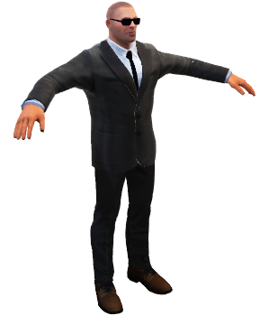

Figure - T-Posing Model of the Security Enemy

### Implementation of Subtask 5C

Before the player can enter the final puzzle, the antagonist is rendered on red alert. He will send his strongest security official to deal with the player: the Senturion. This hulking bodyguard will have 255 health and deal 40 base damage with each attack. The Senturion serves as the miniboss of the game. Once he reaches half of his current health, he will split into two enemies that have the same health as before the split.

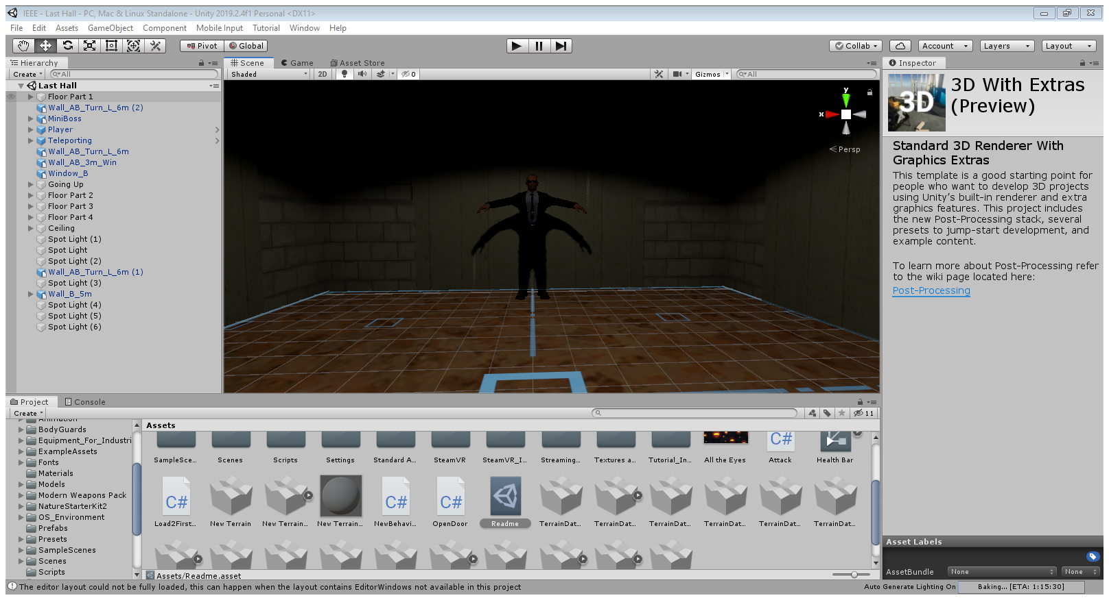

Figure - The Senturion in Question

Of course, the boss does not have just one Senturion at his disposal. He has two more at his disposal should the player fail the Final Exam at the end of the game. These enemies should not be taken lightly in any way, shape, or form.

## Implementation of Task 6

The penultimate task of the project involves creating the final room the player will explore in the game: the main lobby. Here, the player will explore a normal facility that completely contrasts what the player was navigating up until now. There will be NPCs to interact with as they go about their daily lives in the facility and the last encounter with the antagonist himself and an ending event that will send players over to Tyler’s virtual reality game-based learning application.

### Implementation of Subtask 6A

The following two figures showcases the main lobby. The first figure shows two NPCs standing about. They are slacking off in the corridor behind the lobby, but they mean no harm to the player. The second figure shows one NPC tinkering with the facility’s equipment. He is going to ignore the player and focus on his job at hand.

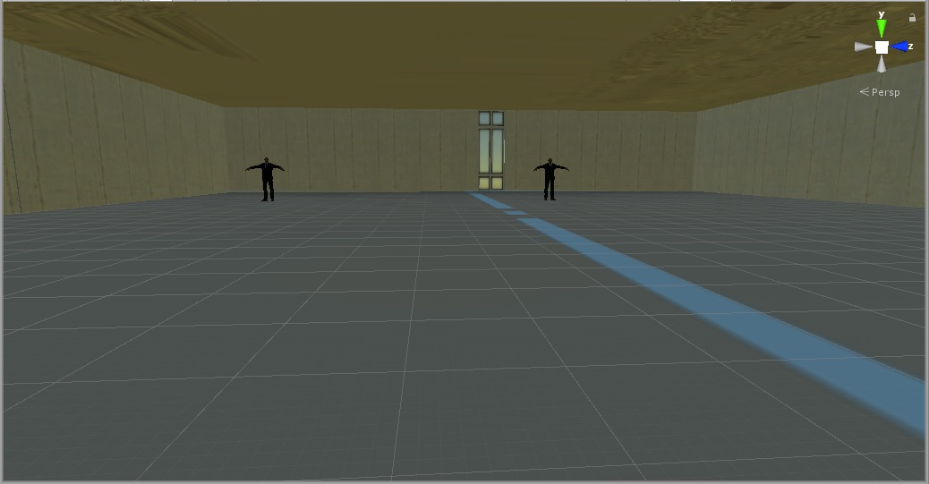

Figure - Two Workers Slacking

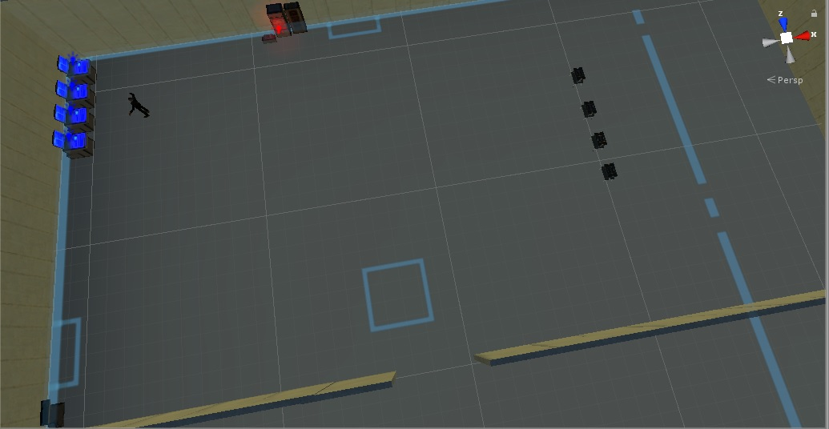

Figure - Overhead View of the Working NPC

The next figure showcases what is outside the front lobby of the facility. Here is a plane that is meant for employees when they are sent to other facilities around the world. Unfortunately for the player, this plane is ready to take them to an alien space craft somewhere in space. Regardless of the outcome of the Final Exam, the player is forced to enter the plane and be sentenced to this space craft. Of course, they can try to escape the space craft; but the premise for that escape is showcased by a similar project done in the past.

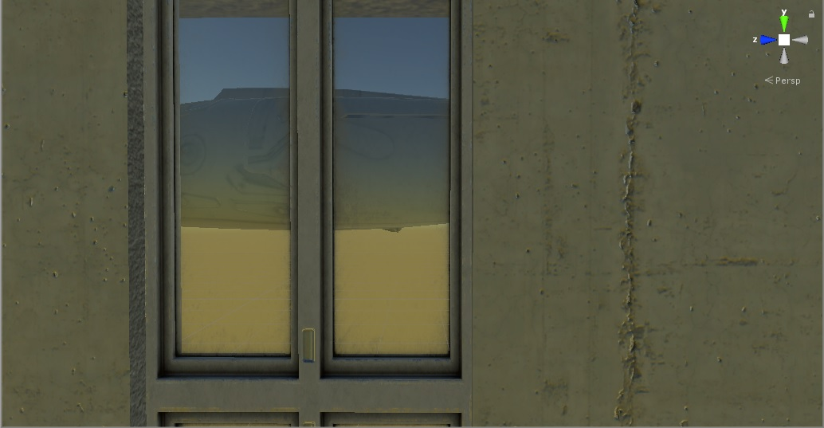

Figure - The Plane to Space

### Implementation of Subtask 6B

At the front of the main lobby, the player will encounter the main antagonist of the game. He is not happy with the player escaping the facility and potentially leaking his company’s secrets to the nation. This subtask implements his last stand to the player: The Final Exam. Here, the player is forced to answer 5 questions about digital logic circuits using the information learned from the puzzles as a reference. The fate of the player is determined by how many questions they get right.

Should the player get at least 4 right, they immediately clear the game, but not without being placed on the plane and out into space since the boss does not want to take any chances. On the other hand, he will summon 2 Senturions after the player should they miss more than 1 question on the Final Exam. Of course, defeating the two allows the game to end as normal.

Of course, the Final Exam is customizable. The figure below showcases the Main Menu of the game. One of the options is labelled “Final Exam.” Here, the professor using this game in their classroom can tailor-make their questions to suit their class. The only limitation they will encounter is that each question can only have 3 choices.

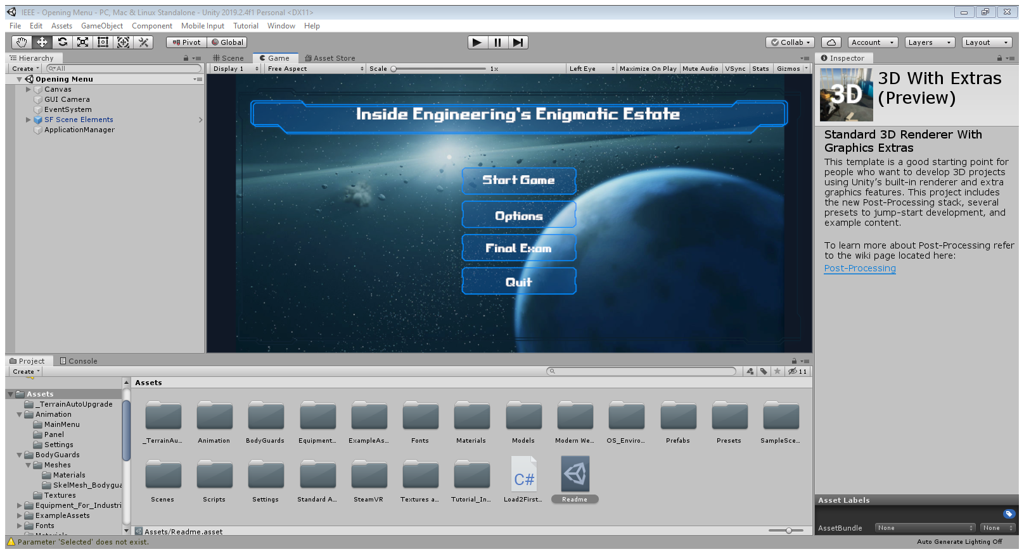

Figure - The Main Menu

## Implementation of Task 7

The final task of this project is to simply verify that the project itself runs smoothly and as bugless as possible. Of course, with virtual reality technology still being relatively infant, a lot of issues with the technology itself often tries to interfere with the project’s completion. This section will go over some of the issues that popped up during the verification process.

The first hurdle is the HTC Vive itself. Throughout the entirety of this project, the controllers would be reversed what they are intended whenever the project was tested for each demonstration. While this problem was circumvented by just playing with the controllers backwards, the problem itself still persisted and was just ignored for the sake of getting everything else done.

The second hurdle involves the testing room itself. A month into weekly testing of the program, one of the bases stopped working. As a result, the main play area for the game was significantly reduced. Of course, implementing teleportation allows easy circumvention of the problem and the game could still be tested as time went on. However, one last hurdle would constantly get in the way of this project’s potential.

One of the assets and program in this project is SteamVR. This asset allows the game to run on virtual reality. Since the technology is still relatively new, the asset would get constantly updated throughout the year. In November, however, one update caused the program itself to not run when the project is loaded on Unity. This problem persisted for a week until a hard reset of the computer allowed the SteamVR application to properly work again.

1. Conclusion (Discussion and Future Plans)

This project taught me a lot about how the video game development process works and the many issues and bugs that would pop up during the process. This project also taught me a lot more about time management and planning. And lastly, this project taught me the uphill battle one person has when making a virtual reality project alone.

This project gave me a better understanding into how video game companies make their games. It is easy to see why various tasks are split among the teams with one doing animations, one doing storytelling, one doing world-building, and so on. The ability to evenly split the work between each team allows the game to be developed in a timely manner with little to no bugs.

Likewise, the above example easily shows the uphill battle I had with developing this project. Having to work on all aspects of the project alone as well as juggling other personal responsibility like the daily commute, work back at home, and other classes does not help in that process. Looking back, the constant juggling of everything that I had to do this year provided me a better understanding of what time management really is and how it will look in the real world.

If I had the ability to, I would not mind going back to this project in the future and letting its full potential really shine. Without a strict deadline in the way, being able to fine-tune the project after the fact would allow me to go back through the bugs I had to gloss over and let my image for what the project is supposed to be really shine. Like with video games today constantly getting updated, this project itself could still be worked on in the future with anyone on the helm to allow the full image of the project to really show to create the idea game-based learning environment for future engineering classes.

Acknowledgment

The assets that were used in the project will be in the Appendix below as well as their creators. For this project, I have two people I would like to acknowledge for their contributions. The first acknowledgement is Chiduben who was also working on a virtual reality module for all of 2019. His assistance with the virtual reality lab and allowing the virtual reality to work allowed this project to really kick off and not be a pile of meaningless screenshots.

The second acknowledgement is Tyler. He worked on a game-based learning VR module from 2018-2019. The ideas and execution in his own project provided motivation and influence within my own. Without learning about the SteamVR asset and teleportation, this project would have never escaped the first room of the game. His game’s setting also provided the perfect ending and sequel hook to my own.

Appendix

1. Assets Used
2. Standard Assets – by Unity
3. UI – by Unity
4. SteamVR – by Valve
5. Bodyguards – by Batewar
6. Modern Weapons Pack – by 7XF Desifn
7. Modular Factory Environment – by Ogasoda
8. Equipment for Indurtial of Science – by Sevastian Marevov
9. Nature Starter Kit 2 – by Shapes
10. Source Code.
11. Basic Enemy.cs

using System.Collections;

using System.Collections.Generic;

using UnityEngine;

using UnityEngine.AI;

public class BasicEnemy : MonoBehaviour

{

private NavMeshAgent _nav;

private Transform _player;

private BasicEnemyHealth _enemyHealth;

// Start is called before the first frame update

void Start()

{

_nav = GetComponent<NavMeshAgent>();

_player = GameObject.FindGameObjectWithTag("Player").transform; //Searches for Player Location.

_enemyHealth = GetComponent<BasicEnemyHealth>();

}

// Update is called once per frame

void Update()

{

_nav.SetDestination(_player.position); //Gives Chase to Player

/* if (_enemyHealth.HP > 0)

{

_nav.SetDestination(_player.position); //Gives Chase to Player

}

else

{

_nav.enabled = false; // Can't have dead enemies aggroing, can we?

} */

}

}

1. Basic Enemy Health.cs

using System;

using System.Collections;

using System.Collections.Generic;

using UnityEngine;

public class BasicEnemyHealth : MonoBehaviour

{

public float HP = 25; //Basic Mooks will take 3 hits

//At Base Damage 10

private Animator _animator;

void Start()

{

_animator = GetComponent<Animator>();

}

public void TakeDamage (float damage)

{

if (HP <= 0)

{

return;

}

HP -= damage; // Count the Health down.

if (HP <= 0) // Enemy Defeated

{

Death();

}

}

private void Death()

{

_animator.SetTrigger("Death");

}

}

1. PlayerHealth.cs

using System.Collections;

using System.Collections.Generic;

using UnityEngine;

using UnityEngine.UI;

public class PlayerHealth : MonoBehaviour

{

public Slider HealthBar; // Player Health Display

public float maxHealth = 100;

public float damageMod = 1; // 0.75 after 1st puzzle. 0.5 after 3rd puzzle.

private float _CurrentHealth;

void Start()

{

_CurrentHealth = maxHealth; //Set HP value

}

// Update is called once per frame

public void Damaged(float damage) // When Hit

{

_CurrentHealth -= damage * damageMod; // Enemy Damage * Damage Mod

HealthBar.value = _CurrentHealth; // = New Current Health

}

}

1. Boss Enemy.cs

using System.Collections;

using System.Collections.Generic;

using UnityEngine;

using UnityEngine.AI;

public class BossEnemy : MonoBehaviour

{

private NavMeshAgent _nav;

private Transform _player;

private BossHealth _enemyHealth;

// Start is called before the first frame update

void Start()

{

_nav = GetComponent<NavMeshAgent>();

_player = GameObject.FindGameObjectWithTag("Player").transform; //Searches for Player Location.

_enemyHealth = GetComponent<BossHealth>();

}

// Update is called once per frame

void Update()

{

if (_enemyHealth.HP > 0)

{

_nav.SetDestination(_player.position); //Gives Chase to Player

}

else

{

_nav.enabled = false; // Can't have dead enemies aggroing, can we?

}

}

}

1. Boss Health.cs

using System.Collections;

using System.Collections.Generic;

using UnityEngine;

public class BossHealth : MonoBehaviour

{

public float HP = 255; //Boss must be chufty :P

private Animator _animator;

void Start()

{

_animator = GetComponent<Animator>();

}

public void TakeDamage(float damage)

{

if (HP != 0)

{

return;

}

HP -= damage; // Count the Health down.

if (HP <= 0) // Enemy Defeated

{

Death();

}

}

private void Death()

{

_animator.SetTrigger("Death");

}

}

1. Aggroed.cs

using System.Collections;

using System.Collections.Generic;

using UnityEngine;

public class Aggroed : MonoBehaviour

{

Animator _animator;

GameObject _player;

private bool _collidedWithPlayer;

private void Awake()

{

_player = GameObject.FindGameObjectWithTag("Player"); // Search Player

_animator = GetComponent<Animator>();

}

private void OnTriggerEnter(Collider other)

{

if (other.gameObject == _player) // Mook meets player

{

_animator.SetBool("IsNearPlayer", true);

}

}

private void OnTriggerExit(Collider other)

{

if (other.gameObject == _player) // Player escapes mook

{

_animator.SetBool("IsNearPlayer", false);

}

}

void Attack() // In Combat

{

if (_collidedWithPlayer) // Mook fights player

{

_player.GetComponent<PlayerHealth>().Damaged(10); // 10 for basic mook. 20 for elite mooks. 40 for the boss.

}

}

}

REFERENCES

1. 3 Shots: This is from base player weapon stat where their damage for each shot is 10. It will increase to 30 by endgame.